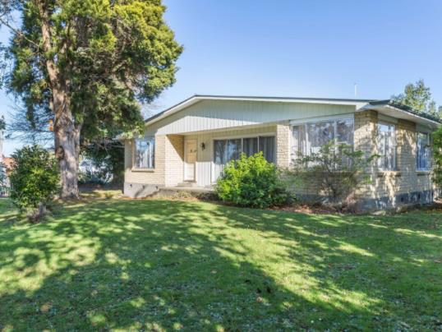
Welcome to our home

Sample image
Right click to replace with
photo of home or family

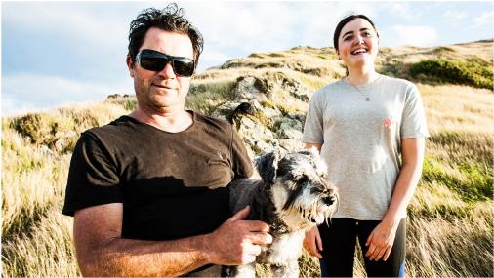
Nice to meet you!

Sample image
Right click to replace
with photo of caregivers

Include a short blurb about each of the caregivers: name, occupation, interests, how long they have been caregivers (if applicable).
About us: Our culture. And how may this play a role in the way the family lives.
Language: What language is spoken in the home?
Include the caregivers’ feelings about the new placement – for example, ‘We can’t wait to meet you and are happy to have you in our family.’
TIP: One of the most common questions coming from tamariki who have been in care has been ‘Are they kind?’. If this can be conveyed in this section, it could greatly put the child’s mind at ease.

Our home
This section describes the physical environment. Some commonly asked questions by tamariki are:
- Will I get my own room?
- Will I be able to store my belongings somewhere?
- Is there somewhere I can go to be alone?
- Is there an upstairs?
- Is it warm? Is it clean and dry?
Prompts around disability – for example, if there are wheelchair ramps.
IMPORTANT TO INCLUDE: Tamariki want to know whether the home and community is safe. Emphasise any elements of safety that the home will provide – for example, the house is back from the road, quiet at night, friendly neighbours.
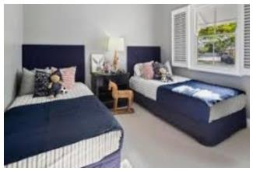
In the photo boxes below, include a photo of the home or the child’s room or any other relevant photos.
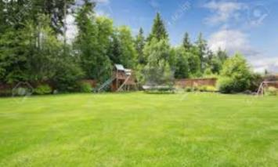

Sample images
Right click to replace

Who else lives here?
For each other person living in the home (besides the caregivers), include:
- first name
- age and gender
- their relationship to the caregiver
- their interests, sports, hobbies (optional)
- personality traits (optional).
Remember to include any pets!
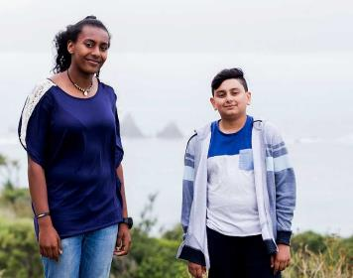
In the photo boxes below, insert a photo of each person living in the home (check that the caregiver has asked their permission).
Name of person (or pet!) in the photo
Name of person (or pet!) in the photo

Sample images
Right click to replace

Our visitors
Only include this section if it’s relevant.
For each person who frequently visits the home, include:
- first name
- age and gender
- what their relationship is to the caregiver
- how often they come over
- how long they usually stay.
Also include if the child will be allowed to have their friends over.
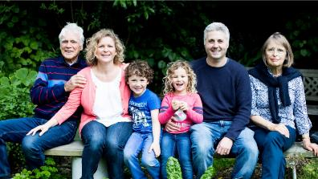
In the photo box below, include a photo of any regular visitors (check that the caregiver has asked their permission).
Name of regular visitor

Sample image
Right click
to replace

Family routines
This section is where to add information about day-to-day life in the household. Suggested content based on tamariki insights are:
Routines
What regular activities does the family do? Suggested examples:
- Here’s how we get ready in the morning (list the routine, especially who will take the child to school)
- We go to church each week. You can come too if you like, but you don’t have to. Or, alternatively: there are churches nearby – if you’d like to go, we are happy to take you or support you
- We leave a light on in the hallway each night
- The pets sleep outside
- We eat dinner at the table each night (you may want to include here what kinds of food the family likes to eat – for example, we love to get fish and chips on a Friday night OR if you like cooking, you can help or cook a meal for us)
The way we do things
- For example, we get our chores finished before any screen time is allowed
- For teens, include curfews, discipline, levels of independence they will have
What happens
This section is to help alleviate any of the child’s fears. This can be tailored based on the child’s age but some suggested sections are:
If I have an accident?
For example – It’s not a problem. Just come let us know and we can remake the bed. We have lots of clean sheets!
If I have hurt myself or I’m worried about something that’s happened?
For example – Come and tell us. No matter how it’s happened, we will sort it out.
If I do something that is not ok or causes concern?
For example – We will talk to you about it and work out why it happened together by talking, not by yelling or getting angry.
If I get hungry?
For example – Just ask and we can get some food together. We always have plenty of food.
If I feel scared at night?
For example – It’s ok to feel scared, and it’s normal. You can have a nightlight if that helps.
When I miss my family?
For example – We will always listen if you need to talk. We’re always here for you.
Here are some things we can talk through when you get here:

Things to do for fun!
Include in here what the family likes to do for fun, or what activities there are to do in the house or in the neighbourhood.
Are there toys to play with?
Is there a garden?
Information on the neighbourhood:
What is the neighbourhood like (without disclosing the location) – for example, there is a park across the road with a slide, near the marae, pool, library, river, etc
Kids want to know, ‘Will I get to have screen time? Is there wi-fi?’
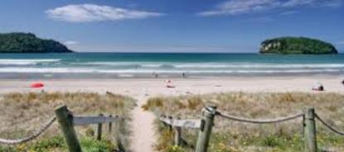
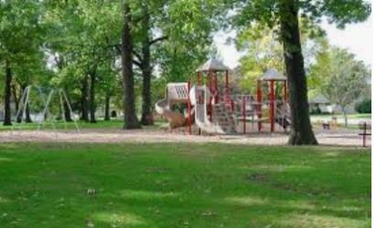
In the below boxes, include photos of the fun things mentioned – for example, nearby park, toys, garden or any other relevant photos.

Sample images
Right click to replace

Any thoughts or questions?
Here is a space for you to write down any questions or things you want to remember to talk about.
This can be a drawing or a list – whatever you like!

SAMPLE IMAGE
right click to replace
SAMPLE IMAGE
right click to replace
SAMPLE IMAGE
right click to replace
Name of the people in the box above
Name of the people (pets!) in the box above

