How To Guide
PURPOSE
The purpose of this document is to assist you with step by step instructions for creating, recording and maintaining the All About Me Plan in CYRAS.
ALL ABOUT ME PLAN
The All About Me Plan helps us support the needs and objectives of te tamaiti, by recording planning information that is responsive to their changing needs and circumstances. This includes what we are doing to strengthen whakapapa connections, to enable and support the whanaungatanga responsibilities of whānau, hapu and iwi, and promote mana tamaiti by supporting te tamaiti to achieve their goals.
The purpose of the All About Me Plan is to:
- describe the support and services in place to meet the needs of te tamaiti identified in their Tuituia assessment, and who is responsible for providing that support
- help te tamaiti understand, in language that makes sense to them, what is happening in their lives, how they will get the support they need, and ensure their voice is heard
- support tamariki to live in a safe, stable and loving home from the earliest opportunity
- promote well-being by ensuring tamariki get the support and opportunities they need to establish, maintain and strengthen their whānau, hapū, iwi and wider family connections when they can’t live with them
- provide detail to help achieve the agreed outcomes of a family group conference or court plan that are specifically relevant to the care of, and support for, tamariki
- enable the flexibility to capture and respond to the changing needs and circumstances of tamariki
- help ensure caregivers and others involved with tamariki have the information they need to carry out their roles and responsibilities
- create a historic record of planning information about te tamaiti
PRE-REQUISITES
- Prior to starting the All About Me Plan, you would have opened a new case for the tamariki/rangatahi.
- From CYRAS > Go into Person Search > Find the tamariki/rangatahi > Open the record and the Person Details tab will open
PRE-POPULATION/AUTOMATION
The first All About Me Plan pre-populates information from an approved Tuituia Report and/or CYRAS, where possible.
- Demographic information will come from CYRAS
- Hopes, Dreams and Wishes will come from an approved Tuituia Report
The second and subsequent All About Me Plan information is slightly different with where it draws information from:
- Demographic information will still come from CYRAS
- Hopes, Dreams and Wishes will now come from the previous All About Me casenote
- Previous information completed in the All About Me Plan casenote, will flow through to the new All About Me Plan

HOW TO CREATE AN ALL ABOUT ME PLAN

- Open the tamariki case in CYRAS and select the Case History tab | 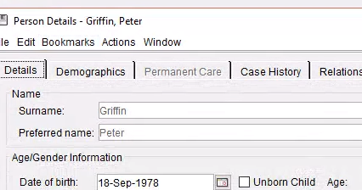
- Choose the Phase Type Placement

If the tamariki doesn’t have a Placement phase opened. Open a new Placement phase

The All About Me Plan will sit under the Placement Phase, under the All About Me Plan folder

- Once the Placement Phase is opened, click on the All About Me Plan folder.  - Click on New Casenote  There is no 7-day lock-down on this casenote | 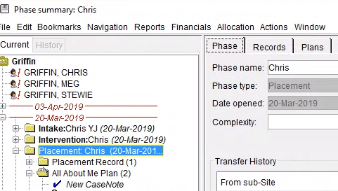
- A new casenote will open up.  Type = All About Me Plan  Title = Type in the first and last name of the tamariki  Click on Create | 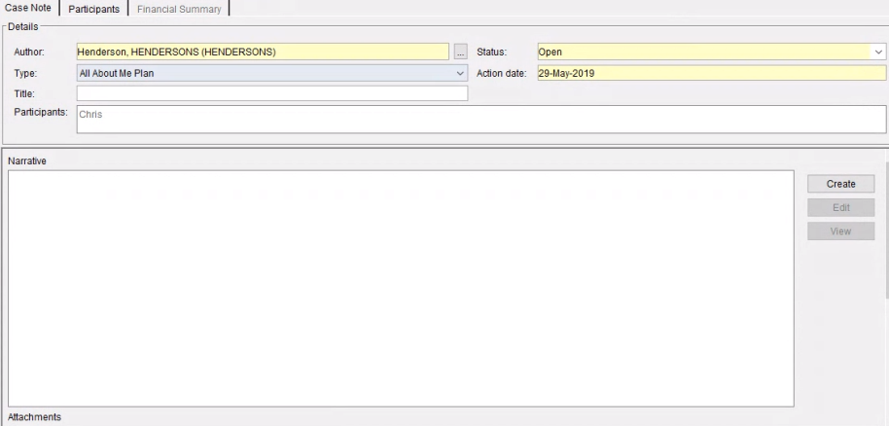
- A new template will open up.  The All About me Plan is sectioned into three parts.  Part 1 will mostly pre-populate with information you have entered into CYRAS.  Parts that are not pre-populated will appear blank.  Fill in any additional information you have  All the sections are editable, even the pre-populated sections.  Anything in the brackets you can change. Prepopulated information can be updated, however all information should be updated in CYRAS so that it automatically populates in future plans  The pre-populated information will still need to be checked for accuracy.  You can bookmark any other plans or casenotes into the All About Me Plan. Read the CYRAS Handbook on how to use bookmarks in CYRAS | 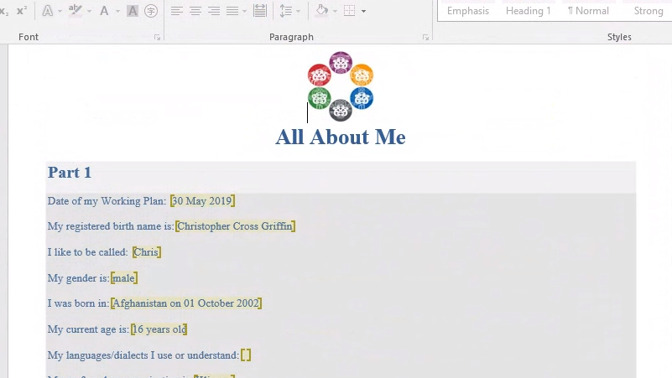
- Scroll down the template to Part 2.  Part 2 will mostly pre-populate with information you have entered into the approved Tuituia Report on the first time you create a new AAMP casenote.  Fill in any additional information you have.  If you are creating subsequent All About Me Plan casenotes, the pre-populated information will pull from the previous All About Me Plan casenote, NOT approved Tuituia Report. If Tuituia has changed, you will need to copy the updated information into the plan  If there is not an approved Tuituia Report available, this section will be blank. You can go back and create/update the Tuituia Report when you have information | 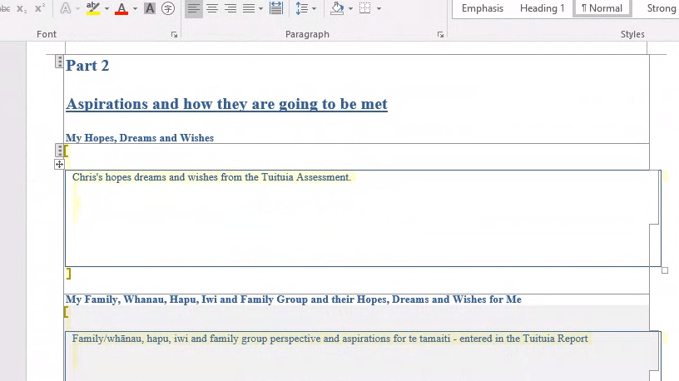
- Scroll down the template to Part 3.  Fill in any additional information you have.  The Outcome/Objectives need to align to any FGC and/or Court Plans  Red text – is hidden text that will assist you to be able to fill in the sections | 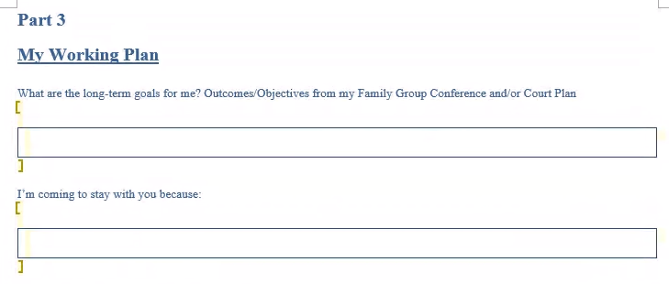
- Scroll down to the tables in Part 3.  Fill in any additional information you have.  Red text – is hidden text that will assist you to be able to fill in the sections | 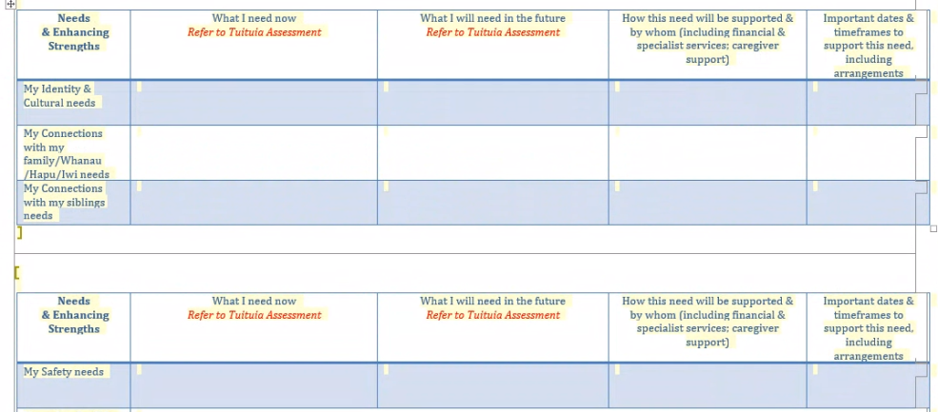
- For Transitional support, use this section.  For any transitions the needs of the child will need to be assessed, and the All About Me Plan completed or updated as usual. For any additional transitional support, complete this section  My Transition between placements Needs or My Transitions to Independence Needs. | 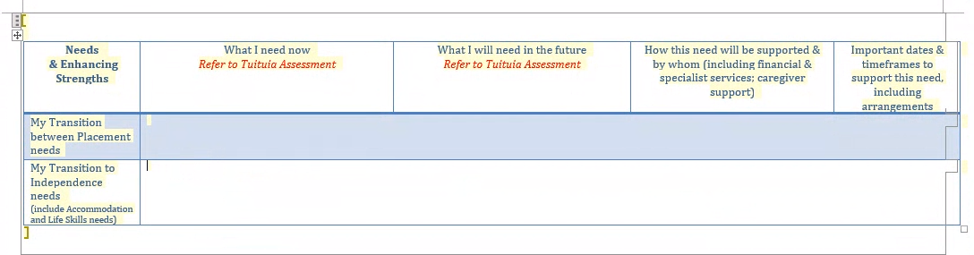
- If the tamariki/rangatahi has a dual tag EG: The tamariki is also in Youth Justice, add a bookmark to their Youth Justice Plan(s) here.  Read the CYRAS Handbook on how to use bookmarks in CYRAS | 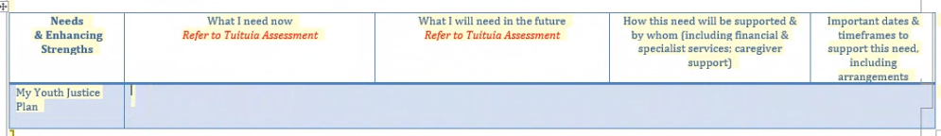
- Once finished updating the All About Me Plan, close the template, by clicking on the X. | 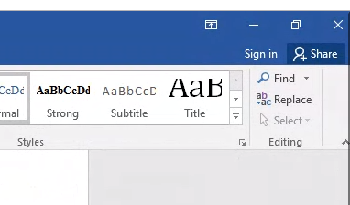
- A pop up box will appear, click Save | 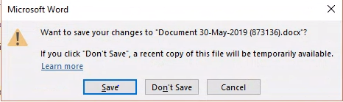
- The Template information will appear back into the Narrative of the casenote.  If you notice any errors, you can click Overwrite to start afresh. | 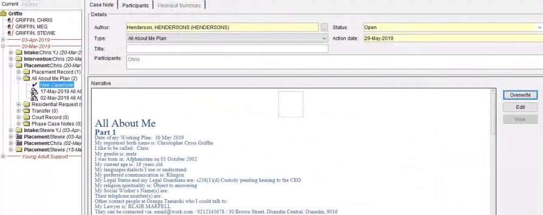
- If you chose Overwrite, a pop up box will show. Click Yes to overwrite  All changes will be deleted. If you wish to edit, click the Edit button | 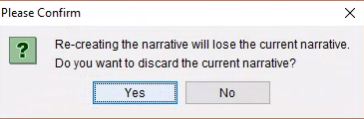
- Once you are happy with the current plan, click Save at the bottom right | 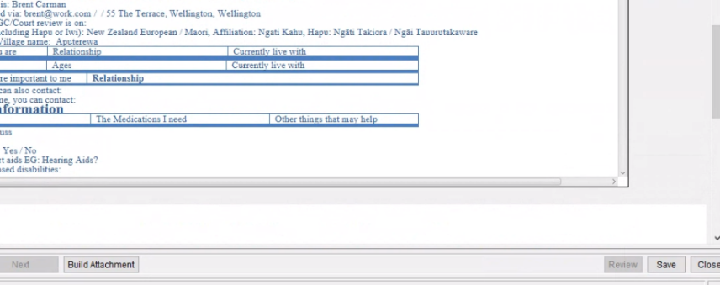
- The All About Me Plan is a casenote, which means only the Author of the casenote can Edit the plan.  To change the Author, the Author clicks on  the … at the top of the casenote, next to the Author.  A new window will open. Type in the new staff members name who you want to edit the plan. Click Search.  Once you have found the correct staff member, click Select.  This will take you back to the All About me casenote where you can see your changes. | 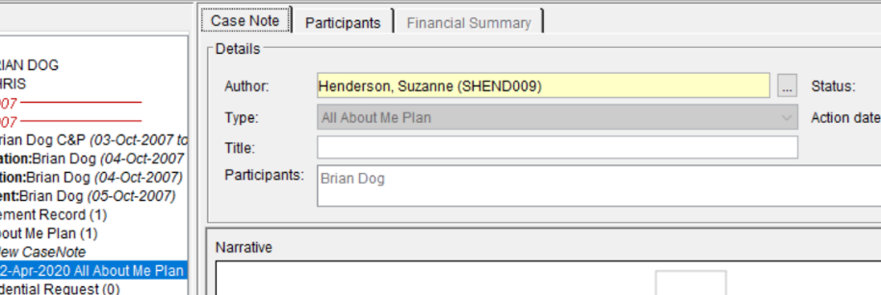  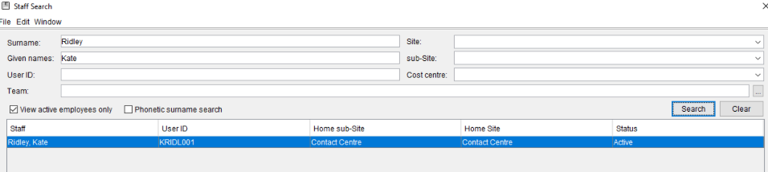  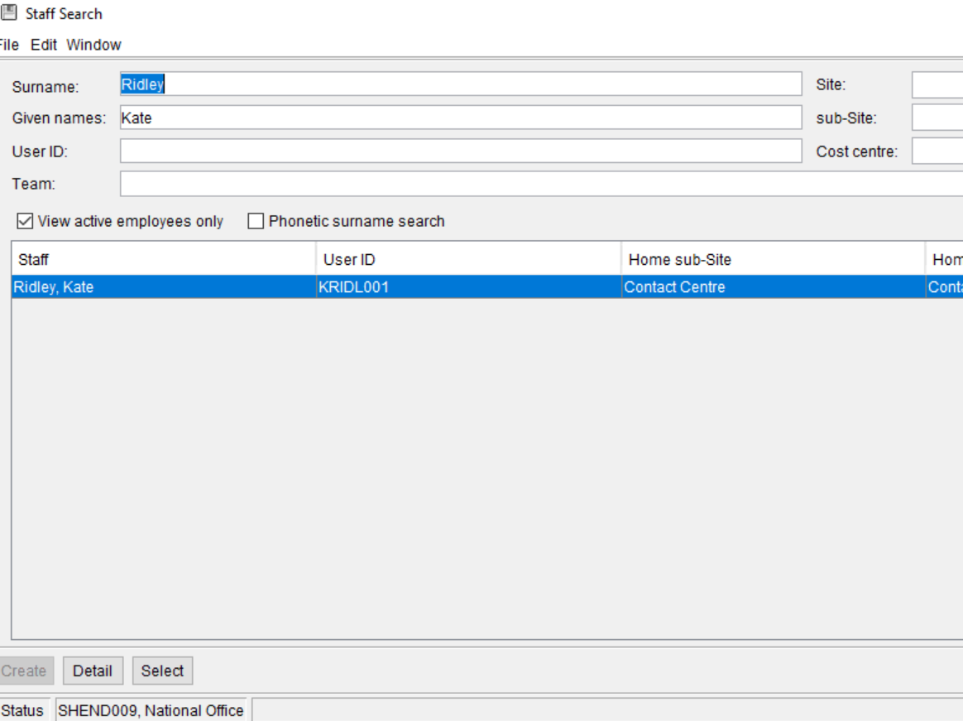  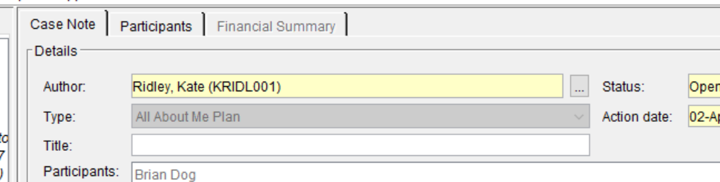
- As the All About Me Plan is a living document, you can edit the Plan at any time.  Click Edit and update the relevant sections that have changed. | 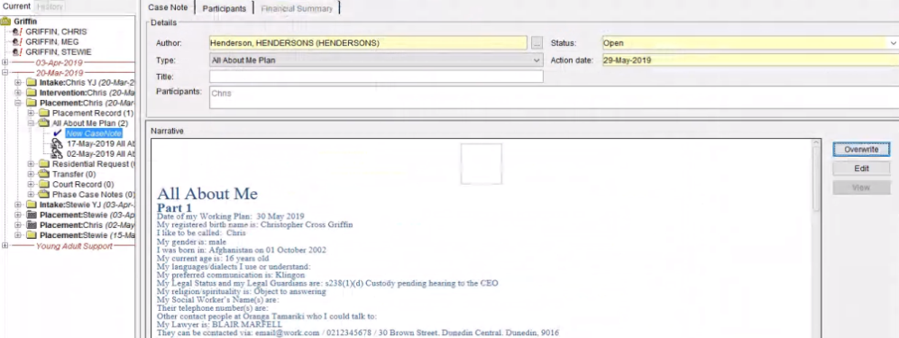
- For sharing the plan with different audiences, printing or exporting click Build Attachment | 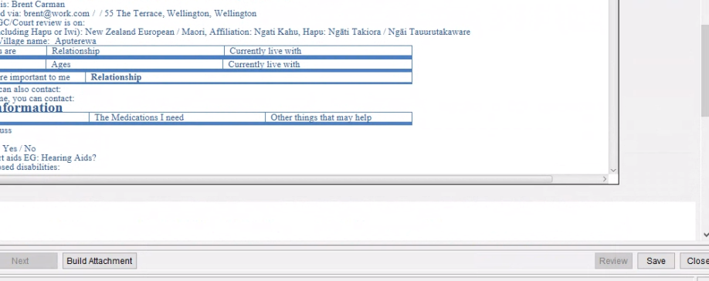
- A pop up box will display.  Select which parts of the plan you would like to print or share, by using the tick boxes | 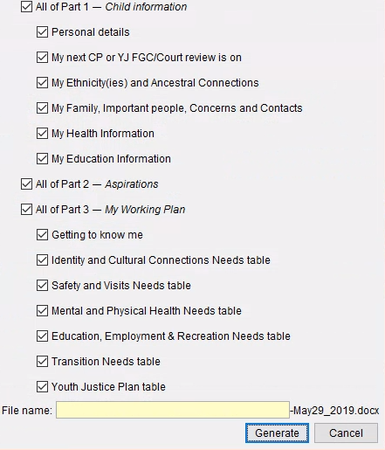
- Once you have selected the sections you want, type in who you are sharing this plan with in the File name box.  Examples include Caregiver, Teacher, Mum, etc | 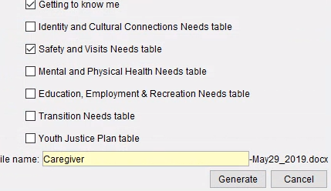
- Click Generate at the bottom right and a pop up box will confirm that the attachment has been generated | 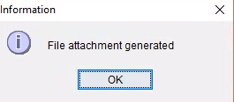
- The sections you have generated will be displayed in the Attachments section of the casenote for you to print or add to an email  The attachment file name will be what you typed into the above step, and the current date.  EG: Caregiver-June04_2019.docx  The description of the attachment automatically displays each section selected  The Tamariki All About Me Plan can be saved as an attachment on the casenote to keep all versions of the plan in the same place | 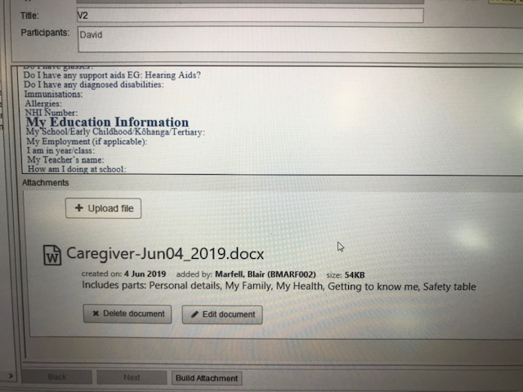
- The attachment linked to a case note is indicated by the paperclip icon in the left-hand menu | 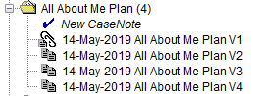

EDITING THE FILE NAME
- After you have saved down an attachment, you can edit the name of the file.

Click on Edit Document
- You can edit the Name of the file or the Description  The attachment itself cannot be edited once you have generated the document. | 